Town Team Board Update – July 2025
This update report has been produced in lieu of the Board meeting planned for July 23rd but which has been cancelled due to known holiday absences.
Sevenoaks Business Show
This was held on 13th June. All the stalls were sold out and there was a reserve waiting list. The speakers were Inspector Mike Alvey of Kent Police giving an update on policing in the town, and Nicki Rundle & Jason Crow, the Sevenoaks BID Ambassadors, updating progress on its development.
After the show Survey Monkey was used to assess the views and reactions to the Show. The outcome is appended.
Sevenoaks BID
The BID Steering Committee has met four times, and this has given a good insight into the aspirations of its members in creating the Business Plan. Work is now progressing on the development of the BID Budget and content of the written plan.
Public Realm
In the last few weeks various locations around the town have been refreshed. These have included:
Painting:
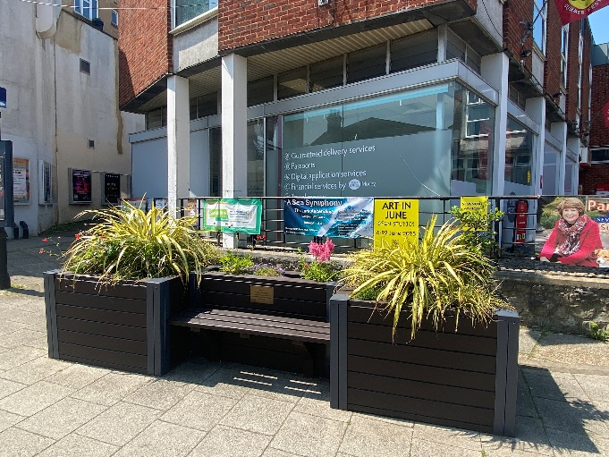
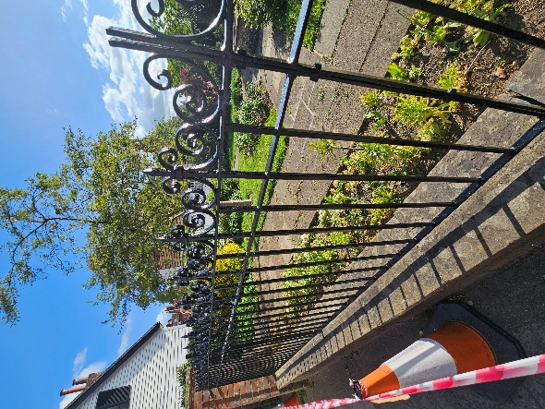

- The railings and step nosings at Upper High Street Gardens
- The “Warners” bench and flower planters at the Post Office
- The Vine tea hut (to be completed soon)

Wash down:
- The white railings and bollards by the Royal Oak
- The white lampposts and street furniture at the Vine
- The fountain at HSBC
- Three water troughs
- The steps to the House in the Basement
- The round bollards at Blighs Car Park (courtesy of Barclays Bank staff)

New Events
Last year saw the first Sevenoaks Bike Show Sevenoaks Bike Festival (wisperbikes.com).and relocated Sevenoaks Street Food Festival Heart of Sevenoaks Events in Sevenoaks — Heart of Sevenoaks taking place on the Vine. The Town Team is not the principal organiser of either event but has a significant role in facilitating and marketing them both. They were both a success and will be taking place again in September.

Britain in Bloom
The Town Team only has a minor role to play in preparing the town for judging. This year it was responsible for securing Purelake as the main sponsor with NFU Mutual becoming a flower bed sponsor and receiving the assistance of its staff in undertaking voluntary gardening. Apart from social media recognition and a High Street banner the sponsors have been recognised using wooden signs planted at the Vine.
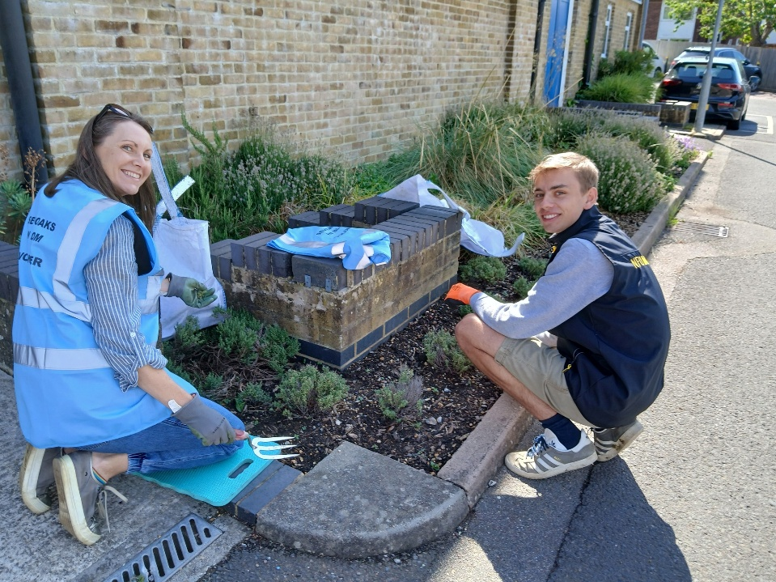

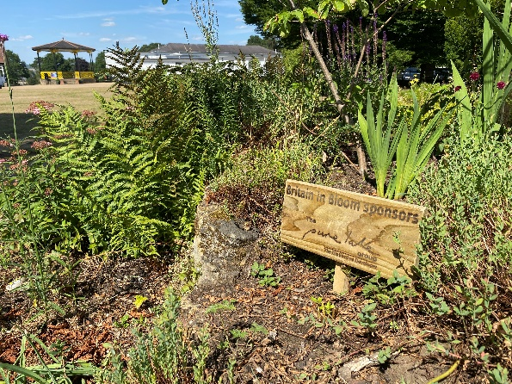
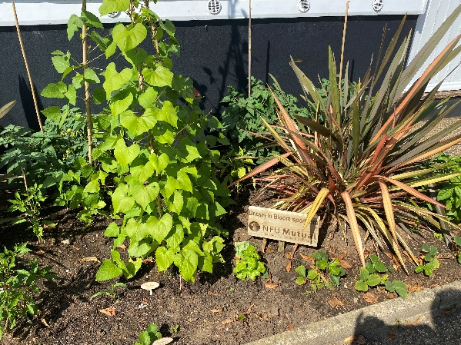
As part of the judging process STC gives a presentation to the judge/s prior to their tour. For the South East Region competition there was just one judge and for the forthcoming National Competition there will be two.
Neither competition assesses the town on just “pretty flowerbeds” but also on topics such as community involvement, an assessment of the hours spent by volunteers, sustainability, interaction with business, the money invested in relevant maintenance and improvements etc. The Town Team Facilitator took part in the South East presentation where the judge was very happy with the ongoing improvements to the public realm seen since 2021, and particularly the uplighting of the trees at The Vine.

Britain in Bloom Best Dressed Window Competition
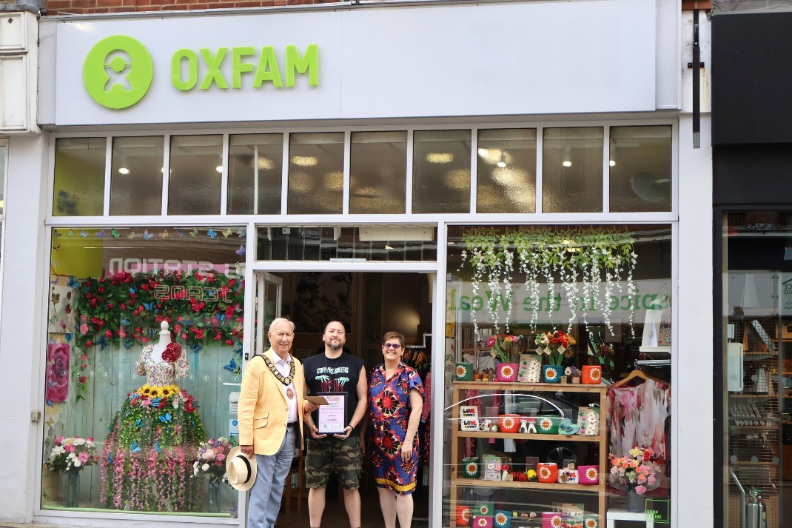
First Place – Oxfam

Second Place – Hospice in the Weald

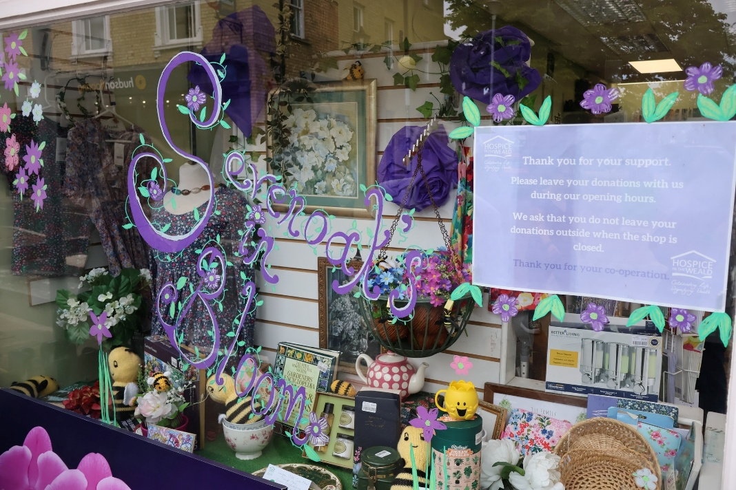

Health Initiative
In a conversation initiated by Jason Crow of The Better Body Group, a new project is being developed. The aim is to promote an overall plan to maintain and improve the health of residents. The scheme would be wide ranging involving, NHS, schools, sports clubs, restaurants, retailers of associated products etc. More details as the discussions progress.

Next Meeting
This will take place on Wednesday 17th September.

