Sevenoaks Town Team
Minutes of the Annual General Meeting

6:30pm: Wednesday 12th November 2025

Held at
The Council Chamber, Sevenoaks Town Council, Bradbourne Vale Road TN13 3QG

Meeting started 6.30 p.m. Meeting concluded: 7.45pm

Executive Board

Cllr Nigel Wightman | Sevenoaks Town Council | Apologies
Cllr Victoria Granville | Sevenoaks Town Council | Present
Cllr Libby Ancrum | Sevenoaks Town Council | Present
Linda Larter MBE | Sevenoaks Town Council | Present
Mike Reid | Town Team Facilitator | Present
Cllr Graham Clack | Sevenoaks District Council | Apologies
Cllr Richard Streatfeild MBE | Kent County Council | Present
Cllr Tony Clayton Chair | Sevenoaks Rail Travellers Association | Present
Austin Blackburn | Go Coach | Present
South Eastern | Jack Heidry | Absent
Andrew Eyre | Stag | Present
Rebecca Ibbotson | Knole | Apologies
Dawn Blee | Chamber of Commerce | Apologies
Steve Butler | Workman (Blighs) | Absent
Sevenoaks Chronicle | Vacant | Absent
Richard Baxter | Sevenoaks Society | Apologies
Shane Smith | Leisure Centre | Absent
Maxine Morgans, V Chair | Specsavers | Present
Elizabeth Dolding | Warners Solicitors | Apologies
Roberta Ware | Francis Jones Jewellers | Present
Avril Hunter | Redlands RA | Present
Elizabeth Purves | Hollybush RA | Apologies
Byron Brown | Bradbourne RA | Apologies
PC Nick Hubbard/  PC Tom Costin | Police | Present
Cllr Dr Merilyn Canet | Sevenoaks District Seniors Action Forum | Present

In attendance: Dennis Glasspool, Jim Hughes, Andrew Pring (representing Knole Paddock RA), Cllr Varley, Cllr Dixon, Cllr Camp.

- Apologies for Absence

Geraldine Tucker (who, having become Chair of The Sevenoaks Society has now stood down from the Board and been replaced by Richard Baxter).
Richard Baxter
Elizabeth Purves
Liz Dolding
Graham Clack
Roddy Hogarth
Byron Brown
Dawn Blee

- Election of Chair of Sevenoaks Town Team

Cllr Tony Clayton, stood down before being nominated by Linda Larter to become Chair for 2025-2026, a motion which was carried unanimously. He went on to congratulate the whole Sevenoaks Team for the town’s success in both the 2025 regional and national Britain in Bloom competitions

- Election of Vice Chair of Sevenoaks Town Team

Maxine Morgans, stood down before being nominated by Linda Larter to become Vice Chair for 2025-2026, a motion which was carried unanimously.

- Declarations of Interest
None

- Minutes
To receive and approve the minutes of the Sevenoaks Town Team Executive Board meeting of 17th September 2025.

- Annual Report

The Annual Report had been circulated in advance of the meeting and there were no points arising which were not covered later in the AGM agenda.

- Finance matters

An abbreviated finance report was reviewed. It was noted that the outcomes to date are:
- Business Show – surplus of £2,325
- Business Awards – which were to take place two days later, too early to determine
- Holly Party – ticket sales in progress
- Spring Vegan Market- surplus of £439. Autumn market cancelled due to bad weather
- Business Hub - £735 surplus to date. Whereas the pods have been almost 100% occupied since the hub was opened, despite much advertising, there has been one vacant for about two months, which if it continues, will adversely affect performance.

- Constitution of the Town Team Executive Board.
No new members, though a further residents association is considering.

- Business Improvement District (BID).

The BID Steering Group has met five times. This has resulted in an appreciation of the type of projects that businesses consider will benefit them and for inclusion in the Business Plan.

At the most recent meeting the budget was discussed, with the main topics being:

The cost of staffing. Overheads have to be kept within 20% of the overall income of the BID and so discussion was held on how many staff it would take to run the BID effectively. The general consensus revolved around one full time and one part time employee. It is planned to talk to neighbouring BIDs to discover their experiences.

“What’s in it for me”. The current iteration is factually correct, but members felt that the emphasis should be shifted so that voting business can see how they would benefit, specifically from the joint marketing opportunities which would arise.

Levy rate. Gaining the most benefit from the BID is dependent on the amount of income it has at its disposal. A final decision has not been made, but discussion has ranged from a levy rate of 1.5% - 2%. Our neighbours have adopted 1.75%, and presently, though a firm decision has not been made, Sevenoaks will be adopting 1.75%.

The BID tagline. By chance, one member said that we would be wanting the public to “Think Sevenoaks first”, and it has been agreed that this wording would be used as the header on future BID marketing.

- Health & Wellness Initiative

There is one survey running, asking the public about thoughts on improving health and wellbeing. Two of the response graphs are below:

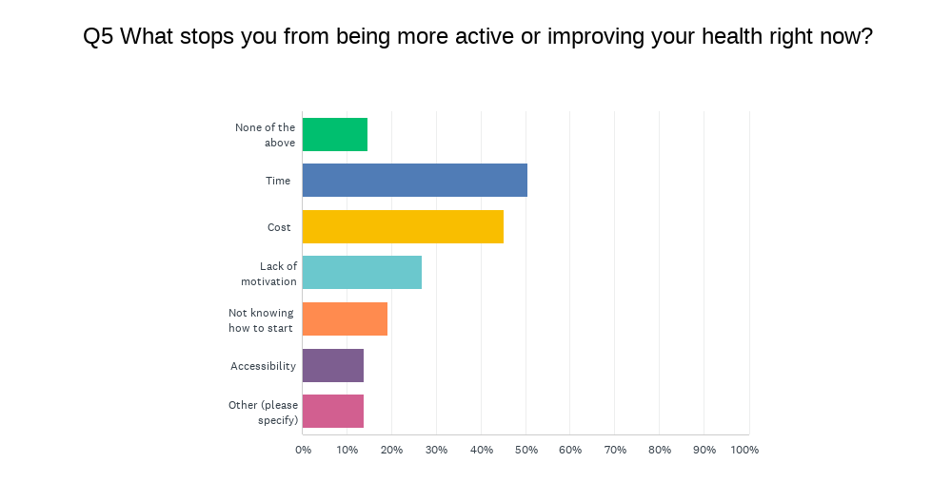

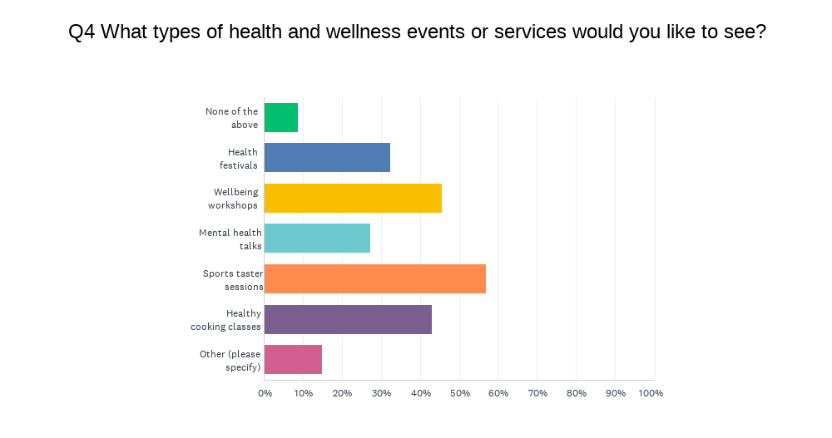

A second survey sent to 63 sports clubs and interest groups and organisations has been started. Its aim is to provide an opportunity for its recipients to build their membership through showcasing at the forthcoming Health & Wellness Fair, and ongoing, through The Town Team creating the most comprehensive directory of such organisations. In time that could be copied over to the BID website.

- Holly Party

Booked for Friday 5th December with a change of format where Jonah’s Wail will be running the whole of the entertainment. Tickets are priced at just £27.50 to include the entertainment and a generous buffet created by Florence of Perfect Cuisine.

- Best Dressed Christmas Window

Once again supported by the Chamber. The judging will take place on 9th December and presentations made on the 16th. It had been noted that more businesses outside the town centre took part in 2024 and it is hoped that their examples (and especially if they win) will encourage their neighbours to take part in future

- Sevenoaks Business Awards

The Awards Evening will take place on 14th November. All tickets had been sold, and a few extra guests had to be shoehorned in.

There have been entries from a wide variety of business types and many have been from names new to the Town Team. In the Customer Choice category, a magnificent 2760 votes were cast.

The main speaker for the evening will be Jenny Ryan, “The Vixen” from TV’s The Chase.

- Reports from Member’s Organisations

Go Coach

All contracts have been extended to mid-2026, and unlike the previous arrangement all routes will be tendered at the same time which will make it easier to plan. School buses are very busy though overall business has not yet returned to pre-Covid levels.

The first electric bus service in Kent, between Ebbsfleet and Swanscombe has been launched, funded by the Lower Thames Crossing and developers.

Specsavers

The recent closure of the High Street due to work on utilities met with mixed reactions from traders and on balance it seems that most preferred it without traffic.

Knole Paddock RA

Residents are very concerned about the proposed development of the land to the east of the High Street and particularly on the likely effects of overlooking and privacy. Residents did not feel that the SDC Local Plan consultation was useful, but just a box ticking exercise.

Kent County Council

Uppermost at the moment is work on Local Government reorganisation. The budget plans have been delayed. Previously budget papers have been sent to Councillors before now, but this time they are not expected before the New Year. Presently KCC is £50m overspent on elderly care.

The delayed High Street closure was due to the contractors having not undertaken accurate surveys before work commenced. Most shops reported that they had a good experience during the closure.

Stag

Very busy!

Kent Police

One new officer “fresh out of the box” is being assigned to Sevenoaks. The police are working on a spate of Anti-social Behaviour incidences which have recently been taking place. A series of Christmas Crime meetings has been warmly received.

Sevenoaks District Seniors Action Forum

Members are concerned about public transport and have a liking for smaller buses. Go Coach reported that Sevenoaks school is running a project about bus services for both young and older people.

Business Crime Reduction Partnership:

Thanks to ShopSafe radios, CCTV, and police teamwork, stores have seen 42 arrests this year.

The Business Crime Forum has reconvened through a Teams meeting, reinforcing partnerships and addressing business-related crime. The session focused on shared concerns, intelligence sharing, and crime prevention strategies. A strong turnout of local store representatives contributed to the discussions.

The BCRP has been awarded the National Standards Award accreditation.

Francis Jones

Very busy and the High Street closure had no noticeable impact.

Redlands RA

Residents are concerned about Regulation 18 and as a measure of that 70 attended the recent AGM. (A Regulation 18 consultation is a key stage in the process of Local Plan making in England. Usually following a 'call for sites', where landowners and developers can submit sites to the LPA to be considered for allocation in the Local Plan)

Croudace is expected to submit a revised application for Britains Lane before Christmas – and which will be opposed by the RA.

Sevenoaks Town Council

The new operator of The Station Café, Lilia, is doing well and her food is exceptional.

Work on the Greatness Pavilion has now started.

The STC electric community bus will be delivered in December and is open for use by community groups at £80 per day plus fuel with the group providing its own driver (who needs only a standard car driving licence).

STC is currently engaged in finalising the Masterplans, Asset Transfers and Budget setting.

Meeting closed at 7.45

Date of next meeting:
21st January 2026

