Sevenoaks Town Team
Executive Board Meeting

6:30pm: Wednesday 17th September 2025

To be held at
The Council Chamber, Sevenoaks Town Council, Bradbourne Vale Road TN13 3QG

Executive Board

Representing | Number | Current Member | Current Organisation
Sevenoaks Town Council | 4 | Cllr Nigel Wightman  Cllr Victoria Granville  Cllr Libby Ancrum  Linda Larter MBE  Mike Reid | CEO / Town Clerk  Town Team Facilitator
Sevenoaks District Council | 1 | Cllr Graham Clack
Kent County Council | 1 | Cllr Streatfeild MBE
Transport | 3 | Cllr Tony Clayton (Chair)  Austin Blackburn  Jack Heidry | Sevenoaks Rail Travellers Association  Go Coach  Southeastern
Leisure Facilities | 3 | Shane Smith  Andrew Eyre  Hannah Kay | Leisure Centre  Stag  Knole
Chamber of Commerce | 1 | Dawn Blee CEO
Blighs Meadow | 1 | Stephen Butler | Workman plc
Sevenoaks Chronicle | 1 | None available
Sevenoaks Society | 1 | Geraldine Tucker
Large Business | 2 | Maxine Morgans (Vice-Chair)  Elizabeth Dolding | Specsavers  Warners Solicitors
Small Independent Business | 2 | Roberta Ware  Vacant | Francis Jones Jewellers
Residents Associations | 4 | Elizabeth Purves  Vacant  Byron Brown  Avril Hunter  Richard Baxter | Hollybush RA  Eardley Road RA  Bradbourne RA  Redlands RA  Drive RA
Police | 1 | Nick Hubbard/Tom Costin | Kent Police
Sevenoaks District Seniors Action Forum | 1 | Cllr Merilyn Canet
 | 27

AGENDA

- Apologies for Absence

- Declarations of Interest

- Minutes

To receive and approve the minutes of the Board Meeting held on 28th May 2025

- Constitution of the Town Team Executive Board.

Any further nominees?

- Business Improvement District (BID).

An update from Tony Clayton

- Wayfinding

Since the last Executive meeting, planning applications submitted by BT for street hubs have all been determined by Sevenoaks District Council. The BT Hubs have been refused both planning and advertisement permission. All of them were consistently on the grounds of distraction to motorists and pedestrians at busy junctions, and unacceptable risk to public safety. Some of them had an additional ground for unacceptable impact to the street scene and character via street clutter.

One of the application files can be seen here:
25/01047/FUL | The proposed installation of 1no. BT Street Hub unit and removal of associated BT payphone kiosks. | BT Street Hub East Of Sevenoaks Post Office London Road, Sevenoaks, Kent And BT Telephone Box North Of 52, London Road, Sevenoaks, Kent, TN13 1AS.

These hubs, or similar ones proposed to the Town Team by Pulsehub, would have provided the major signage planned for the Wayfinding scheme and at no cost to the Town Council.

Since last reporting on the scheme a second application to the District Council CIL committee has also been refused. The first time it was because the committee did not consider the scheme to be “infrastructure”, the second application was refused on the ground of “lack of partnership working”.

Where next for the scheme?

There is an opportunity to apply for a KCC Local Bus Intervention grant which is geared to building bus ridership but does consider bus related wayfinding as a qualifying project. The closing date for applications is 31st October 2025 and details of match funding are required.

Another opportunity would arise through the BID.

- Town Centre Masterplan Public Consultation

An update from Linda

- Health & Wellness Initiative

This is a joint project between The Better Body Group and the Town Team. The concept is based on elevating the general health of Sevenoaks residents through removing barriers and opening opportunities.

A survey is being undertaken as below:

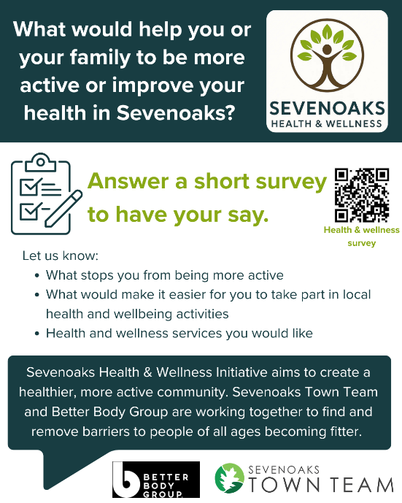

There are a number of conversations taking place about developing this theme with the focal point being in May 2026 when a Health & Wellness Fair will take place on The Vine.

- Sevenoaks Street Food Festival

This took place on Saturday 6th September and was massively popular. All 22 stalls were sold out. The turnout was much greater than expected so there were some issues with rubbish and neighbourliness but “lessons have been learned” for the future. While the Town Team facilitated the Festival, the actual organiser was Caroline Druce-Smith of Heart of Sevenoaks.

- Sevenoaks Bike Festival

This is planned for September 20th and again facilitated by the Town Team and this time organised by Sevenoaks Bikes.

- Autumn Vegan Market

Planned for October 4th, and a joint enterprise between the Town Team and Vegan Markets UK.

- Sevenoaks Business Awards 2025

Remaining timescale:

19th September Midnight: Nominations close and businesses are invited by Sevenoaks Town Team to enter

6th October Midnight: Entries close and the public voting for the Customer Choice Award opens

24th October Midnight: Public voting for the Customer Choice Award closes

14th November: Gala Awards Evening at the Bat & Ball Centre.

As at 9th September nominations for 28 businesses have been received, many with multiple nominations.

- Holly Party

Marketing has commenced



- Members Organisations

To receive updates from partnership members and their organisations activities.

- Dates of future meetings

Wednesday Town Team AGM on 12th November
21st January 2026

